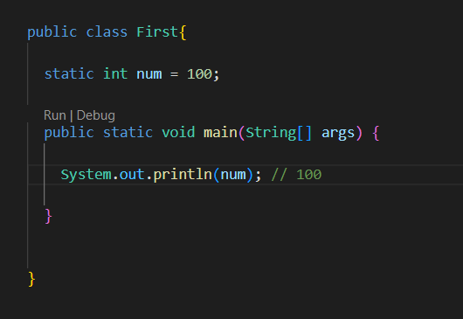

Here num is initialized inside the scope of First class.

So the rule says that, this num will be available to everything inside this scope

Even if there are 100 blocks inside the First class, this num will be available to that 100’th block scope

**When a variable is initialized that variable is available to everywhere inside that block**

Also here num is static because we cannot have an non static variable or function inside the static class, just doesn’t make sense